Scrum - Rituals Workbook

Iterative Time-box Activities

| Analyze |
| --- |
| Design |
| Construct |
| Integrate |
| Test |

Quality of an Iteration

|  |
| --- |

Quality of Outcome Determination

|  |
| --- |

| Sprint definition  The heart of Scrum.  One month or less.  Time box for creating an Increment.  Team determines length based upon their belief of what would work best to enhance team productivity. |
| --- |

| Determination of length of sprint.  based upon their belief of what would work best to enhance team productivity. |
| --- |

Sprint Rituals

| Sprint Planning Meeting | Create a goal that gives direction to the team. Analysis, evaluation, and selection from PB defines Spring backlog |
| --- | --- |
| Estimation | Blind Estimation  Estimate product backlog  Decompose reference story  Identify team capacity  Estimate team velocity  Affinity Estimating  Quickly categorize user stories  Apply estimates to categories  Fast and Furious... |

3 types of estimation When this occurs Unit of measure

| Portfolio Backlog |  | Categories |
| --- | --- | --- |
| Product Backlog |  | Story points/ideal days |
| Sprint Backlog Task |  | Ideal hours/ effort-hours |

Scrum Roles Involved in Estimation

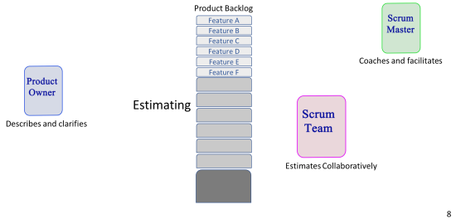Planning Poker Triangulation

All 3 are involved in both

| Ideal day / Ideal hour  Time focused with no interruptions |
| --- |
| Problems with Ideal estimation  You will very seldomly see a day with no interruptions whether that be internal or external interruptions. |

Daily Standup

| Purpose  inspect progress toward the Sprint Goal and to inspect how progress is trending toward completing the work in the Sprint Backlog. |
| --- |
| 3 Questions  What did you do since the last meeting?  What are you planning to do before the next meeting?  Do you experience any obstacles? |
| Rules  The Scrum Master asks the questions. Same place and time every day. For synchronization, not problem-solving. A short meeting may be held after the Scrum meeting to resolve issues (only attended by relevant team members). Time box: 15 minutes daily. It works best if you do it in the early hours of a day. |

Pair Programming

| two developers work together on the code. |
| --- |

Sprint Review Meeting

| Purpose  held at the end of the Sprint to inspect the Increment and adapt the Product Backlog if needed. |
| --- |
| Participants  Scrum team  Scrum Master  Product Owner  Possibly external stakeholders |
| Timing  4 hours max. |
| Location  Decided by Scrum Master |
| Expected Outcomes  collaborate on the next things that could be done to optimize value. This is an informal meeting, not a status meeting, and the presentation of the Increment is intended to elicit feedback and foster collaboration. |

Sprint Retrospective Meeting

| Last activity in a sprint. |
| --- |
| 3 hours max. |
| Reflect on sprint. |
| Improvements of process for future. |
| Review ‘Definition of Done.’ |

Ritual Timing

| Sprint Duration | Max 1 month |
| --- | --- |
| Daily Stand-up | 15 min |
| Sprint Planning | 8 hours |
| Sprint Review | 4 hours |
| Sprint Retrospective | 3 hours |

